Project Report

Group members:

Name- Shubham Saoji
Ufid- 26364957

Name: Rohit Karumuri
UFID: 90971158

How to run project:

Change the addresses of the tbl files in test.cc and main.cc

make clean //to remove compiled files
make //to compile all files
make test.out //to compile test.out
./test.out //to run the compiled binary
make gtest //to compile google test cases
./gtest to run test cases

DBFile Class and Methods:
DBFile Class consists of class members:
- File file object – working binary file
- char *filePath – stores location of the working binary file
- Record *current pointer - stores the address of the record currently being used.
- Page page object – working page of the working binary file
- off_t poff – stores int value of number of pages written in file (useful for writing purposes)
- off_t roff – stores int value the currently reading page (useful for reading purposes)
- bool pDirty – true when currently working page is changed while doing writing operation; false when operation is done.
- bool end – true when reached the end of the file; else false
DBFile Methods:
- DBFile() constructor – creates DBFile object and Record current object.
- ~DBFile() destructor – destroys the Record current object and DBFile object
- Create – Creates a new empty database binary heap file. It returns 1 on file creation and 0 when no file path is given. After file creation, it records filepath of the binary file and initialized values to other members of the class.
- Load – loads all the records from tbl files to the respective database files; appends to the last. Handling: When all the records in tbl file are read completely, the records stored in the page in memory is written to the binary file, making sure all records are written to disk.
- Open – Opens the already created binary file and returns 1. If the file path is not present, it returns 0.
- MoveFirst – Loads the first page of the binary file to memory and assigns ‘current’ pointer to the first record of the page.
- Close – Closes the opened file. Returns 1 when file is closed.
- Add – Appends one record to the page that sits in the memory. When the working page is completely filled up, it writes the page to the binary file in the disk, empties the page in memory and then starts filling up.
- GetNext(Record &fetchme) – Reads the next record of the page in memory and returns 1. If all the records are read in page, it switches to next page. If all pages are done, bool ‘end’ will be true and returns 0.
- GetNext(Record &fetchme, CNF &cnf, Record &literal) – Using a comparision engine, it reads the record which satisfies the CNF statement and returns 1. If all records are done, it returns 0;

q1:
(r_name = 'EUROPE')
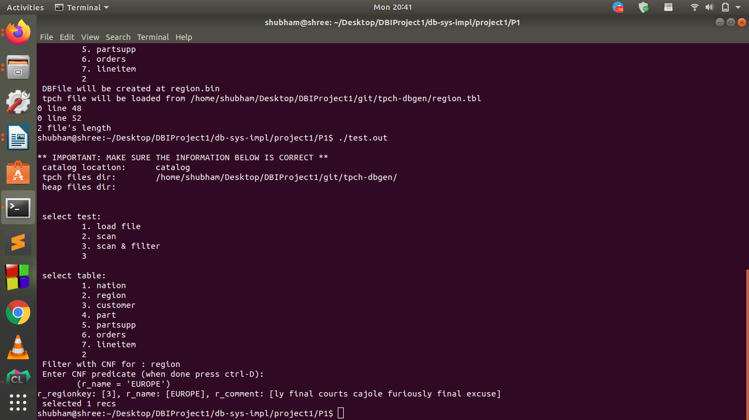

q2:
(r_name < 'MIDDLE EAST') AND(r_regionkey > 1)

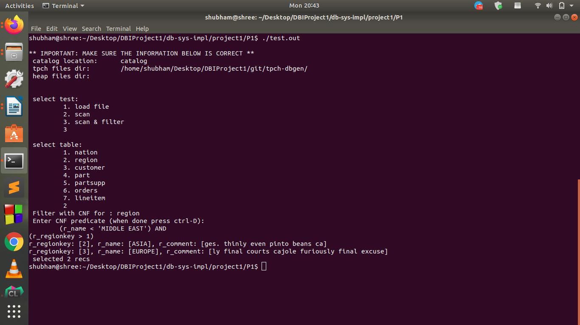

q3:
(n_regionkey = 3) AND(n_nationkey > 10) AND(n_name > 'JAPAN')
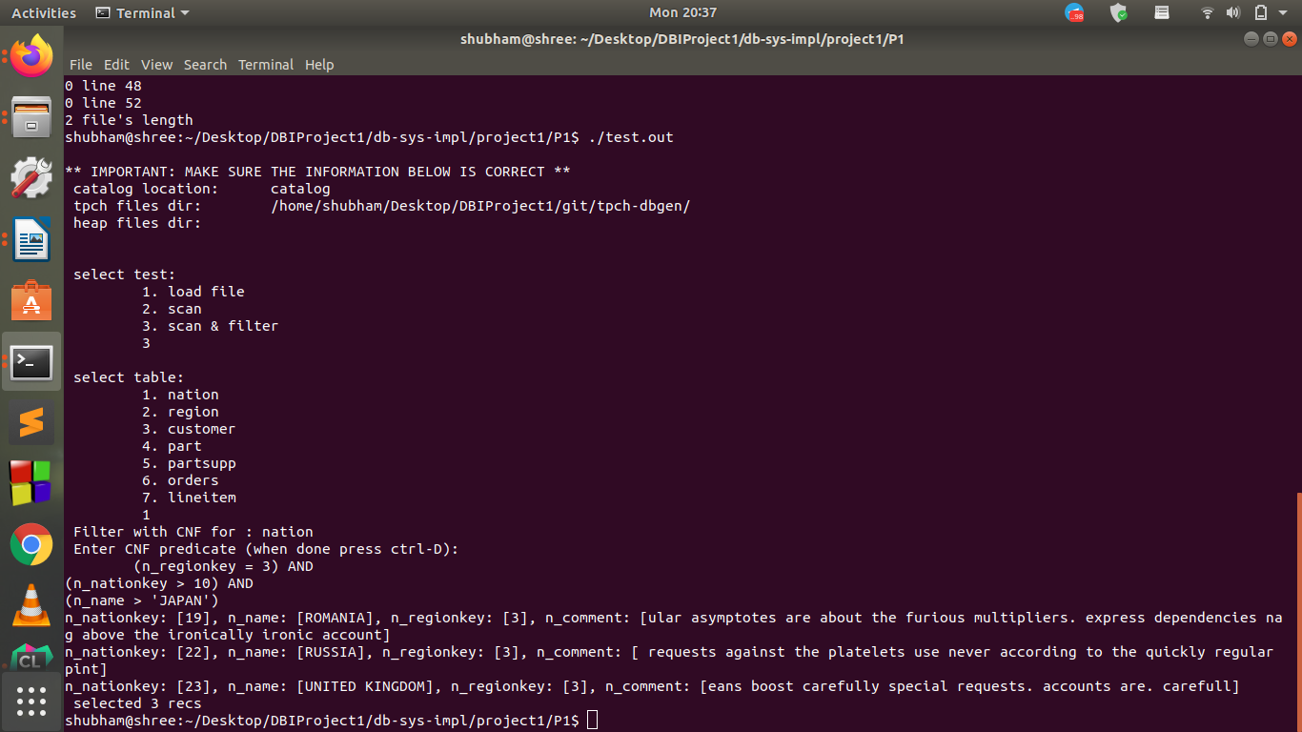
q11:
(l_shipdate > '1994-01-01') AND(l_shipdate < '1994-01-04') AND(l_discount > 0.04) AND(l_discount < 0.07) AND(l_quantity = 4.00)
Note: 0.05 < If l_discount < 0.06 not shows any records because it doesn’t include record when l_discount == 0.05 or 0.06. So changed the value range to include those records similar to shown in output.log file.
Note: l_quantity = 4.00 instead of 4 since the CNF expression takes this field as double instead of int as mentioned in catalog.
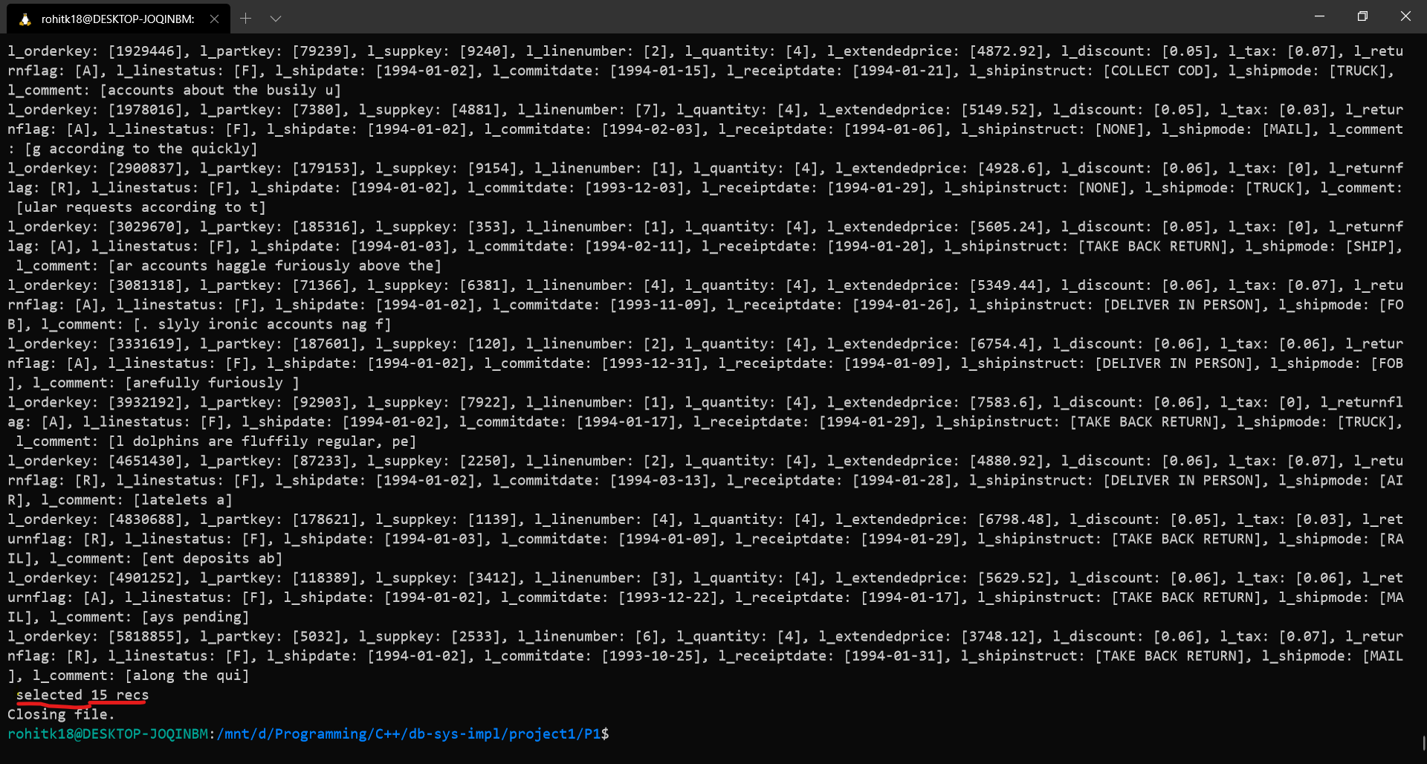

q12:
(l_orderkey > 100) AND(l_orderkey < 1000) AND(l_partkey > 100) AND(l_partkey < 5000) AND(l_shipmode = 'AIR') AND(l_linestatus = 'F') AND(l_tax < 0.07)

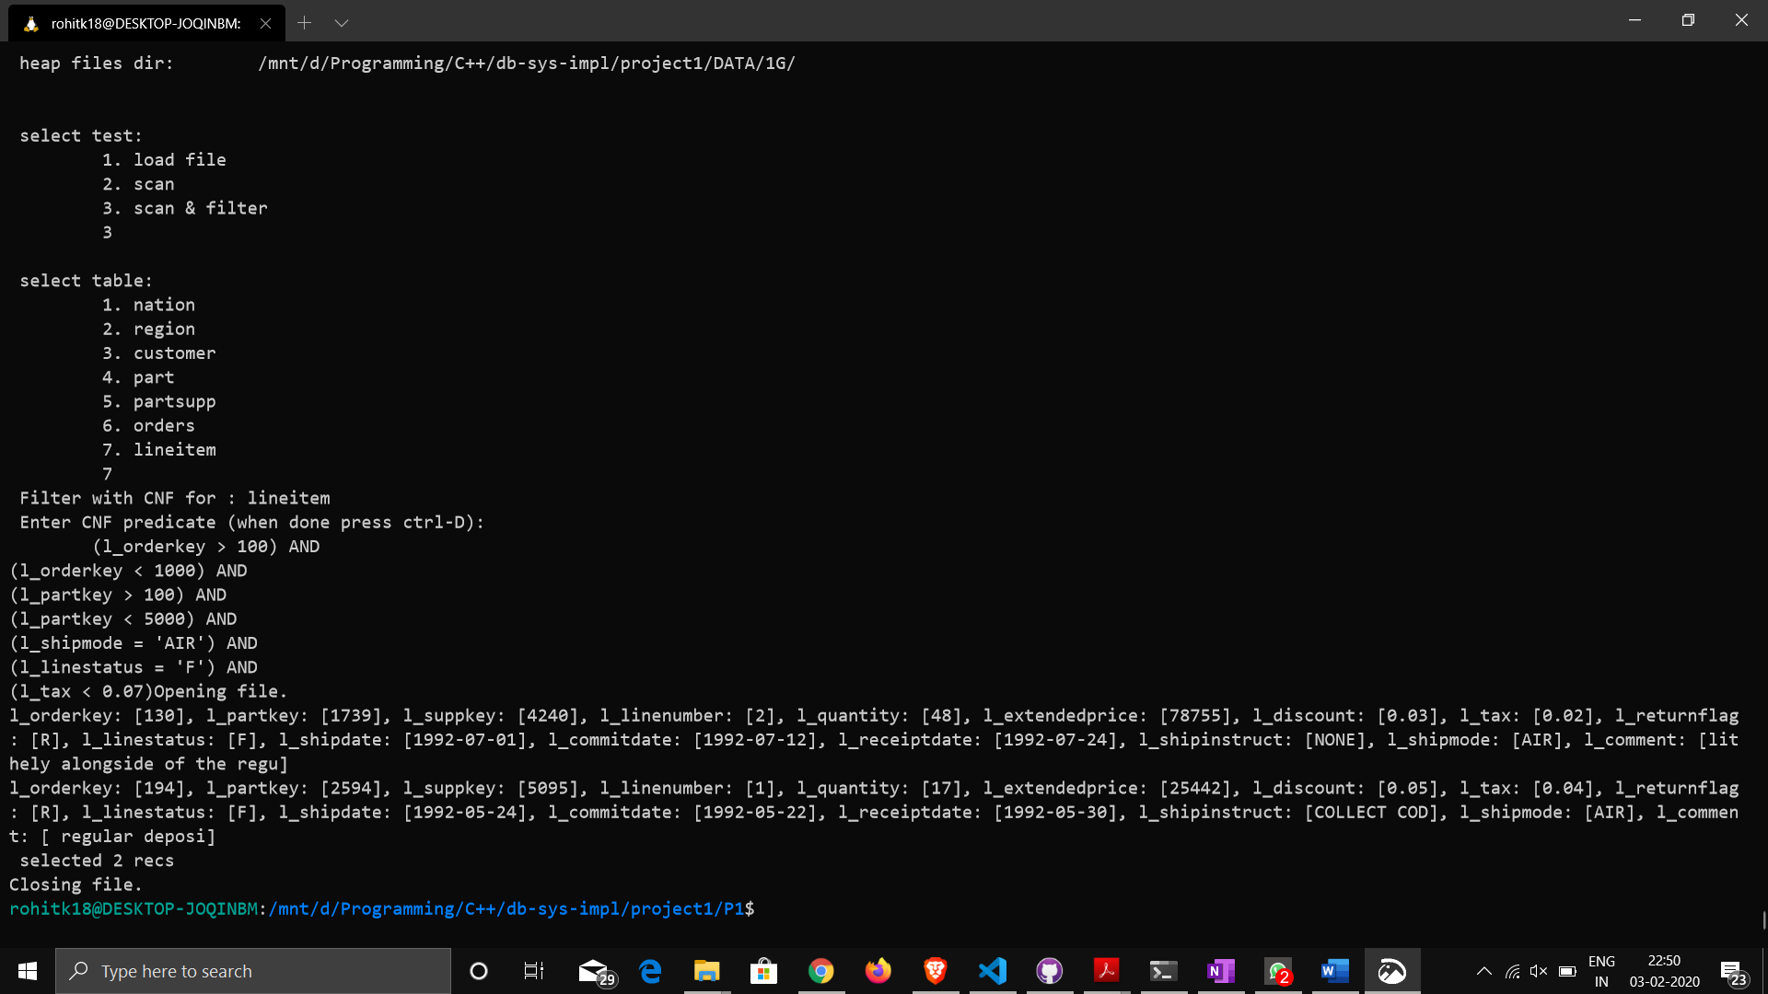

gTest result:

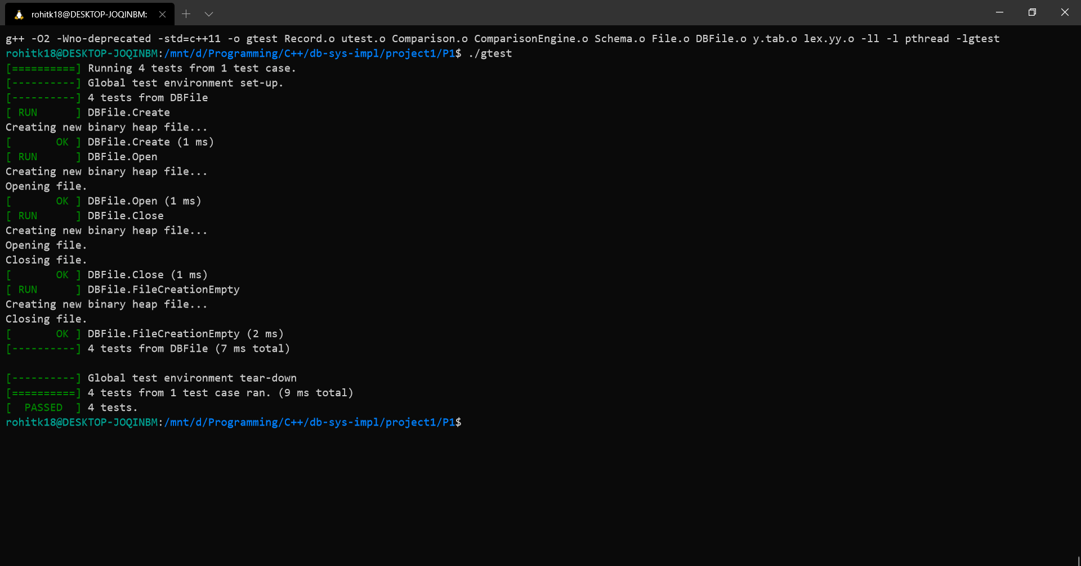
Tests Cases:
- File Creation Test – Tests whether file is created in disk
- File Creation empty or not Test – Tests whether created file is empty
- File Open Test – Tests whether file is opened or not
- File Close Test – Tests whether file is closed or not

